Thermostat User Guide
Segundo North – Alder, Thompson & Miller Halls

The Segundo North buildings are equipped with Johnson Controls thermostats. These thermostats control the temperature in the room based on pre-set limits. Residents can select comfortable heating/cooling temperatures within 3.5 degrees (on either side) of the standard set point by turning the dial towards heat (+) or cooling (-).

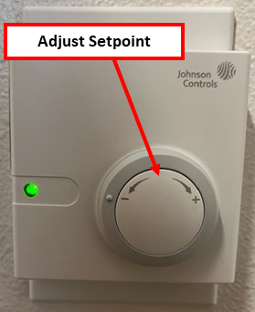
Troubleshooting:
Room is Too Hot
- Look at the dial – is it all the way to the cold side (-)?
If not, turn the dial.
- Are the windows open?
  - If outside temperatures are warmer than inside temperatures, close all windows to allow maximum efficiency.
  - If outside temperatures are cooler than inside temperatures, open windows to allow increased cooling.
Room is Too Cold
- Look at the dial – is it all the way to the heat side (+)?
If not, turn the dial.
- Are the windows open?
  - If outside temperatures are cooler than inside temperatures, close all windows to allow maximum efficiency.
  - If outside temperatures are warmer than inside temperatures, open windows to allow increased warming.
If the above actions do not resolve the problem, please submit a service request on-line (Academic Year Residents and/or Staff). Contact your respective Area Service Desk if immediate response is required.



